Variable Head Solar Grass Cutter Weed Trimmer
Personal lawns, public parks, gardens are a major recreational places but require a lot of maintenance to keep them operational. The major maintenance activity involved here is grass cutting and weed removal. This requires a lot of time and effort on a regular basis to maintain the lawn.
Also the problem with lawn movers and motorized cutters are that they need to be moved by a human thus requiring human effort and moreover depend on either furl or electric charging. These devices involve recurring cost of either fuel or electric charging to keep running.
Well we here solve all these problems with an automated robotic grass cutter that can cut grass of any lawn/garden without human effort as well as it charges itself using solar power without the need of fuel or electric charging.
The solar grass cutter robot delivers following benefits
- It can cut grass with ease using high powered motor
- Variable head to define the grass cutting height
- Heavy Duty body, wheels and drive motors to navigate offroad
- Autonomous motion with obstacle avoidance using ultrasonic
- Motorized drive using DC motors
- Solar powered machine for self charging
The robotic vehicle uses a set of geared motors with wheels, metal robotic frame, ultrasonic sensors , controller circuitry, battery along with a solar panel to achieve this mechanism. The system uses the control circuitry with ultrasonic motors to help move easily through gardens and lawns.
The robotic vehicle is mounted with 4 x Geared motors to deliver the desired torque that will be required to move through lawns and gardens. We use 4 large size rubber wheels to motor shafts that wont get stuck in grass and weeds.
The robotic body is a mild steel chassis that is integrated with 4 Drive motors below it. Also we make a hole in the centre of the frame to mount the grass cutter motor in the middle. The high torque high speed motor in the center is used to move the tool that cuts grass. The grass cutter tool is then attached to the motor shaft so that blades can cut grass below.
The cutter motor mount allows user to loosen the screw and vary the height of cutter motor which allows to define the desired grass cutting height. All these motors are powered by a battery which is charged automatically using a solar panel mounted on top of the robotic frame. This allows for a smart and automated solar powered grass cutter system.

Components:
- Solar Panel
- DC motors
- Robot Body
- Wheels
- Motor Mounts
- Ultrasonic Sensors
- Controller Circuitry
- Bearings
- Base Frame
- Supporting Frame
- Screws and Bolts

Applications:
- Useful for automatic lawn cutting and backyard cutting
- Automatic grass and weed cutting in gardens

Advantages:
- It can cut grass with ease using high powered motor
- Variable head to define the grass cutting height
- Heavy Duty body, wheels and drive motors to navigate offroad
- Autonomous motion with obstacle avoidance using ultrasonic
- Motorized drive using DC motors
- Solar powered machine for self charging
Block Diagram:

Front View
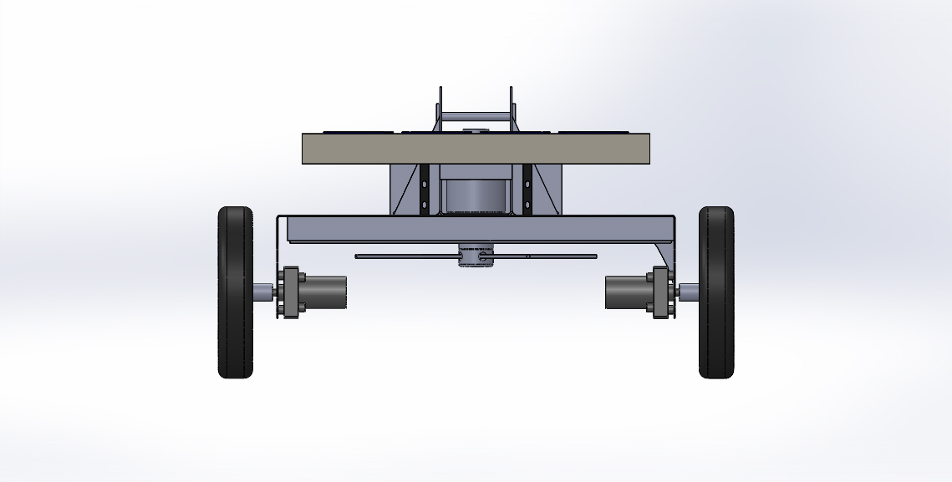

Side View
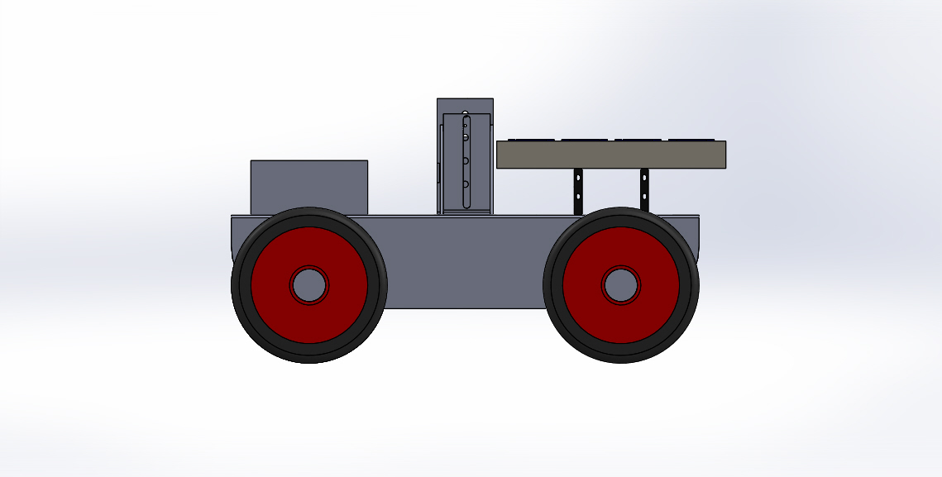

3D View

